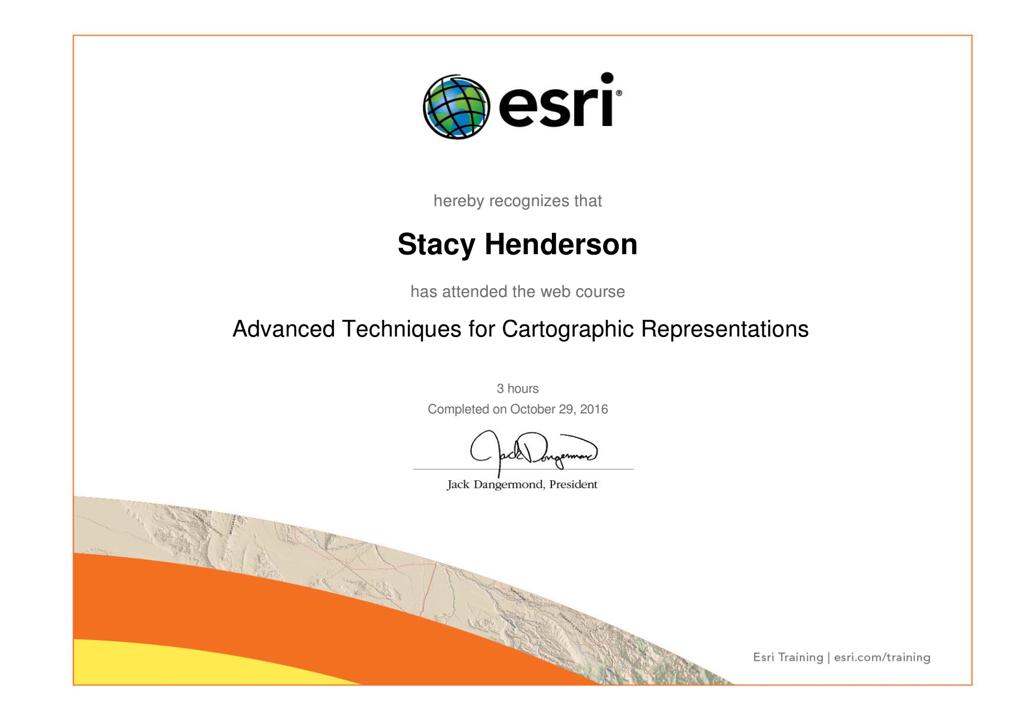
One of my problems with map making is my inability correct visually unappealing aspects to my map in a satisfactory manner. I don’t have an artist’s eye for design and I don’t (didn’t) have the knowledge of how to utilize features within ArcGIS. In fact, I was so new to ArcGIS that I didn’t know the tools in this assignment were even available to be used. Nor did I know correct terminology for the tools, so searching for answers to improve the visual appeal of my map rarely yielded results.
This assignment has both introduced me to tools I wasn’t aware of previously and it has taught me how to use those tools in order to improve my maps; by creating representations of layers which allow me to edit symbology and move it around to create a more visually appealing map. I have a map for a research project I created a year ago and my study area was a narrow canyon, so some of my symbology overlapped, and things just didn’t look quite right on the map. I converted my graphics to annotation to move some of my overlapping points, but I never (even to this day) fully liked how the map looked. I really wanted more robust symbology, something that showed the reader what metals were found at each site at a glance without necessarily needing to refer to the legend.
This training has shown me how I can take my data in that map and create representations that would allow more diverse symbology and allow me to move overlapping symbology without affecting the original data. In addition to just creating representations I could use the tools learned in the Introduction to Cartographic Representations and this training to create a more robust visual of my study area to reflect the type of rock in the area as that rock could be a source of heavy metals discovered in my research. This would allow a scientist reading my map to quickly see what metals were found in what locations and by creating representations within the map of specific rock formations, I could also display the rock layers.
I think these trainings have been the most exciting to me thus far simply because I can see the things I’ve struggled with being corrected with these new tools. These improvements in my map making knowledge were a result of reading the training, interacting with it when applicable, and by going through the exercises in ArcMap in order to actually use the tools.
I know ArcGIS is very robust and I’m going to be learning about new tools and features of the program for a long time to come, but at least I have a more robust set of tools in my toolbox to help me create more visually appealing maps that are easier to read.

