Basics of Geographic Coordinate Systems
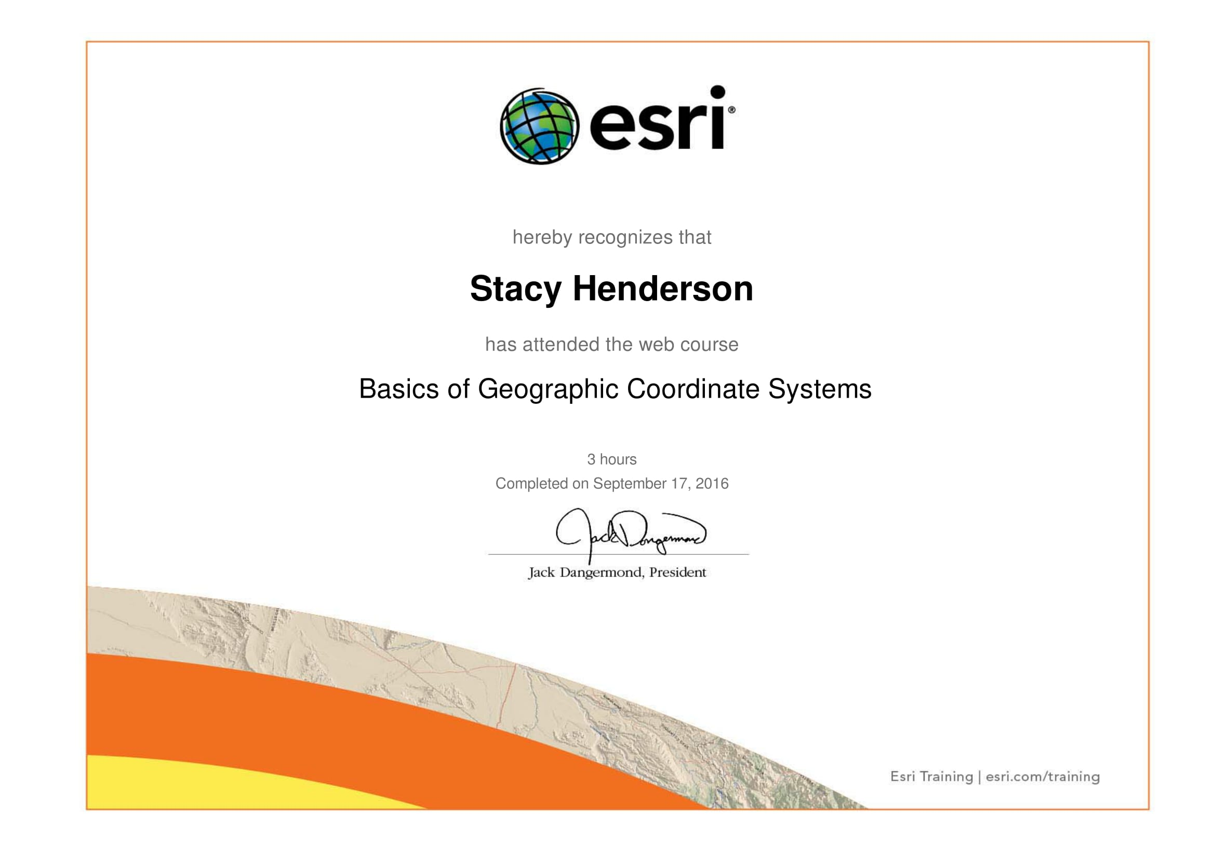
I’ve made quite a few maps in the past for different classes and an internship, and I’ve had to use different Geographic Coordinate Systems in the process. I’ve even had to transform some coordinate systems. Despite understanding why I needed to use matching coordinate systems for different layers, I didn’t fully appreciate the differences. The thing that “clicked” for me in this assignment was simply looking at the map of Long Island, NY with all the different coordinate system layers. I didn’t realize just how different coordinate systems could be, and how that could alter the appearance of my map, or where the points are located on a map. This introduction to coordinate systems made me much more aware of how important this part of map making really is.

