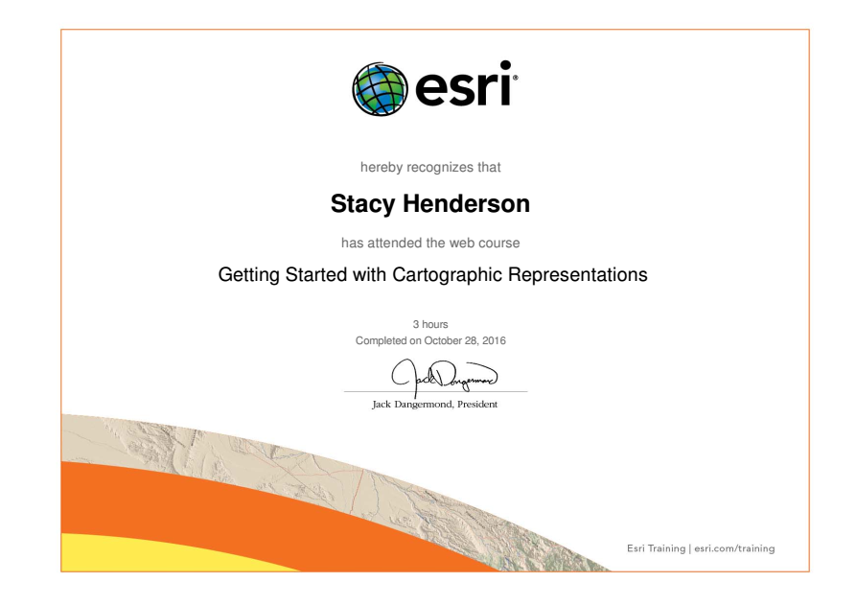
In this training I learned how to easily edit symbology to make a map look better. In my chosen field of Geology I may be required to map rock formations. Geologists symbolize different types of rocks (sedimentary, igneous, and metamorphic) in different ways so a cross sectional diagram is clear to the reader what the layers of rock are. If I needed to do a mapping project showing where rock formations are in a given area, I can easily edit the symbology to look like the symbology Geologists use on a regular basis. Although I may not be using ArcGIS for cross-sectional drawings, being able to edit features or symbols to match what a geologist would be used to seeing would make a very useful map.

