Segments of the San Andreas Fault
The San Andreas Fault is categorized by geologists into segments. The northernmost segment is about 186 miles long. It extends from Shelter Cove to south of the San Francisco Bay area. It’s this segment that ruptured and caused the famous 1906 San Francisco earthquake.
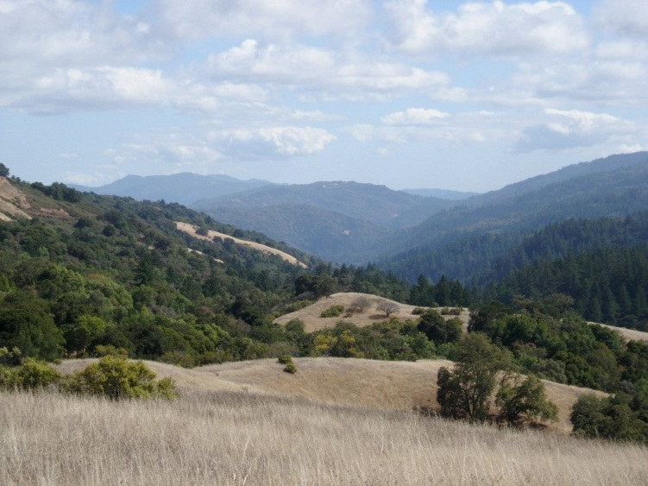
The creeping segment extends from San Juan Bautista to the Parkfield segment. This segment is always in motion and moves about one inch per year. This is called seismic creep and is damaging to buildings, roadways, and other structures.
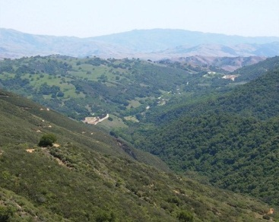
What is it?
The San Andreas Fault is the most prominent fault in a series of faults that form the tectonic boundary of the Pacific Plate and the North American Plate. It is roughly 810 miles in length. It runs northwest from near the US/Mexico border to near Point Delgado, CA.
The fault moves horizontally in what is referred to as a right lateral strike-slip movement. This means if you were to stand on one side of the fault, looking across it, the opposite side would appear to move to the right.
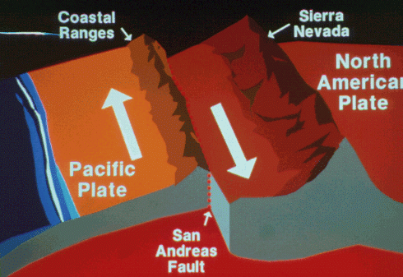
San Andreas Fault

Southern Segment
Central Segment
The Parkfield segment is about 18 miles long. This segment is known for magnitude 6 earthquakes that don’t involve other segments.
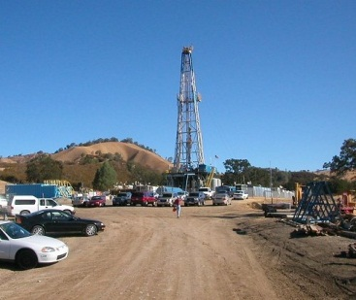
The central segment is most well-known for a magnitude 8 earthquake in 1857 that broke open the ground for 217 miles. This segment takes a large bend near Bakersfield then runs along the southern edge of the Mojave Desert.
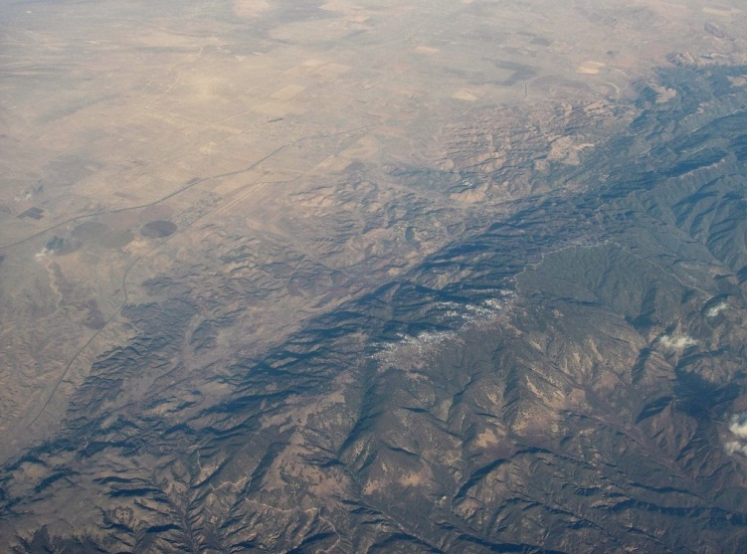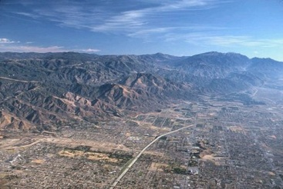
The Southern section runs south from Cajon Pass for about 186 miles to the Salton Sea (a shallow saline lake found in the rift of the fault).

Features of the San Andreas
From the air a linear trough reveals the presence of the fault. Within the trough there are linear arrangements of lakes, valleys and bays.
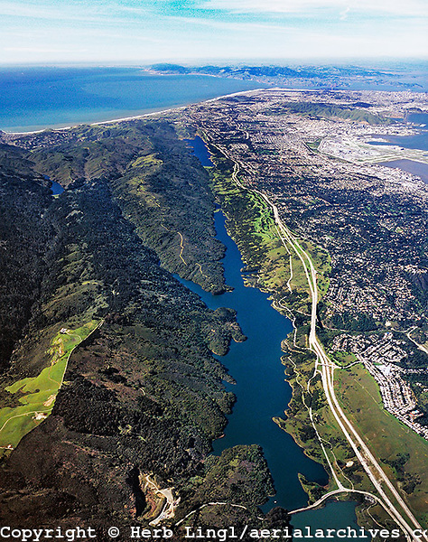
When on the ground the fault is not as obvious, however where streams cross the fault the stream channels will bend sharply to the right.
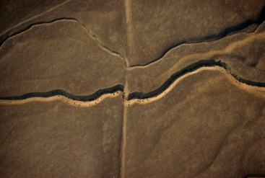
The San Andreas Fault is still shaping the California landscape and will continue to do so indefinitely.

