Should Congress Have Term Limits?
Why I believe they should
Term limits for our House of Representatives and Senate have been discussed and debated since the formation of our country and the constitution. Given that George Mason, Thomas Jefferson, George Washington, Benjamin Franklin, Richard Henry Lee, and James Madison believed term limits should be implemented, it’s surprising that this is something not written into our constitution, or in intervening years implemented as an amendment. George Mason stated, “Nothing is so essential to the preservation of a Republican government as a periodic rotation.” Lee wrote that not having term limits was a “most highly and dangerously oligarchic.”
The more Congress’ approval ratings drop the more private citizens believe there should be limits on our representatives. I believe that realistic term limits which allow a representative to get elected, learn the job, get familiar with how Capitol Hill works, and begin making coalitions to increase chances of effective legislation getting passed are not only a good idea, but necessary.
As of February 2012 the longest serving Democrat, John Dingell (D-MI), has been in office for 57 years; he took office in 1955. The longest serving Republican, Bill Young (R-FL), has been in office for 41 years. How in touch are these men with issues of today? How are they voting on issues that affect an America that is vastly different from the America of the ‘50s and 60s?
The current perception is that our congress is in the pockets of lobbyists, big business, and industry, and that we the people are the least of their priorities, hence the 10% approval rating for Congress. There always has been and always will be room for improvement in any government, but it has reached a fever pitch. The citizens are angry and in favor of term limits believing this will be the change that spurs our representatives into action.
During the course of my research into this topic I’ve found varying opinions, and in the case of California’s state legislature, proof that term limits are not actually working. It appears that people get elected in California and almost immediately start looking for positions within the state government that will allow them to be career politicians in that position. This has, according to some, led to an inept state legislature and the inability to balance the budget and pass bills that will better the state. As of this year, the most tenured person in the state government was Governor Schwarzenegger. If the example of California holds true for other states, it could be argued that we’d have the same problems at the federal level as well.
I believe the answer to this problem is finding the “sweet spot” for term limits; the spot that allows a politician the possibility of a stable career in the House or Senate but forces them to perform better or risk actually being ousted by a challenger, which is very rare currently. Todd Platts (R-PA), has voluntarily left office after 12 years. During his time of service in the House he’s fought to try to get term limit bills introduced and passed, but has had no success. He believes strongly enough in term limits that he’s put a self-imposed term limit of 12 years on himself. He is definitely a unique representative as the only one to currently not only try to get a term limit bill passed, but lives that ideology by leaving office. No other representative that has tried to get legislation in place for term limits has left office and they don’t appear to have plans to leave office of their own accord.
Is 12 years the right about of time? Maybe. It is better than 6 or 8 year limits that have been proposed in the past. "The fact is we have 435 members of the House and 100 Senators," Platts said, "and if you had 12-year term limits, you're gonna have turnover of a portion every two years, not all at once. You're going to retain significant institutional knowledge." 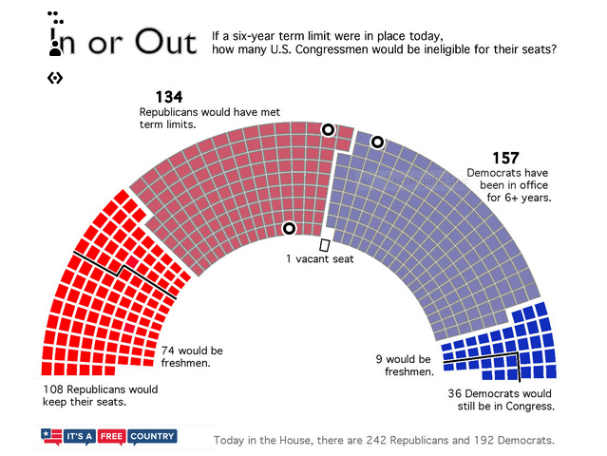
Why term limits? One argument for term limits it to correct the inequalities that currently exist in favor of incumbents. Incumbents receive close to a million dollars a year for free mail, staff salaries, and travel expenses. Challengers do not have this luxury. Incumbents have staffers that can campaign on their behalf; the challenger has only him or herself and maybe a few of their own staff if they can afford it. Often times the challenger has to fight to get sufficient funds to campaign properly and that may have to be financed out of their own pocket. The challenger may have a full time job or career which they would need to quit to campaign. Currently it’s a difficult uphill battle for a challenger and most of the time the incumbent gets reelected simply due to the ability to get their propaganda out to more voters more frequently.
Politicians making laws for people need to know what it’s like to be a regular citizen. Life on the Hill is different from life as a regular person trying to make it every day of every year until retirement (if he/she has the means to retire). After spending 18 years in Congress, former Senator George McGovern failed to succeed in small business. He stated, as a result of his private sector life "I wish I had known a little more about the problems of the private sector.... I have to pay taxes, meet a payroll -- I wish I had a better sense of what it took to do that when I was in Washington."
In The Culture of Spending, James L. Payne notes that there is a correlation between votes in favor of more public spending and length of service. If his findings are accurate, this is why we cannot balance our budge and bring our outrageous national debt down. It’s been argued that the longer a person holds a legislative office the more they come to identify with the federal government and special interests and the less they identify with their constituents. Why would they bite the hand that feeds them? The hand that feeds them is not necessarily the voters given the upwards of 85% reelection rates. The hand that feeds them is typically special interests, and they will not risk all the funding that keeps them in a job year after year.
Special interests are of course against term limits. Shouldn’t this be a red flag? Groups funding so much of our representatives’ campaigns are fighting against term limits? Why? Because they don’t want to lose their investments, investments being the legislators they helped get elected and stay in office in order to have someone on their side of legislative battles.
An argument against term limits is that the limits will restrict the choices available to voters. However, this argument appears to be invalid given the current situation. Right now spending on challengers is decreasing drastically (and has been for years) giving any challenger less opportunity to reach a wide audience with a variety of campaign ads. Campaigning costs money, and the incumbent has an advantage here as discussed above. So with term limits, eventually an incumbent, even if reelected for the entire term, will be forced out at some point. This will allow for a more even playing field for candidates at that time, thus opening the door to many different possibilities for voters that were are not currently available under the current system.
Political scientists argue against term limits as well and for good reason. They helped shape the current problem of professional legislators. That’s not to say that some of their arguments against limits aren’t valid, because they do offer up some interesting points that would be worth studying and analyzing. Realistically most people don’t like to admit when they are wrong, why would a group such as political scientists be any different? In addition, at times, political scientists can come across as elite when their opinions differ from that of a vast majority of the general population. Currently most of the population within the U.S. supports term limits, and given the education of and immersion of political scientists in the political world, they are going to be less likely to agree with the average citizen’s opinion. These are not valid reasons for experts in a field to oppose something so vehemently. The political science academics would better serve the nation by studying and testing their valid reasons for opposing a term limit to help educate us on how truly viable this idea is.
In conclusion, I believe that term limits, set up correctly can be very beneficial to the country. I think it will increase voter candidate options, provide us with candidates that have real world experience, and reduce the influence of outside money from special interest groups. I believe that this is something that needs to be more seriously studied on the state level using the states that currently have term limits and compare and contrast success rates with the varying limits and laws in place in order to know how better to proceed (if we can get that far) on a federal level. Reform is needed, and it’s time it happened.

Sources
Greenberg, Dan. "Term Limits: The Only Way to Clean Up Congress."Conservative Policy Research and Analysis. N.p., 10 Aug. 1994. Web. 17 Nov. 2012. <http://www.heritage.org/research/reports/1994/08/bg994nbsp-term-limitsnbsp-the-only-way>.
Reader, Stephen. " Explainer: Should Congress Have Term Limits (Part 3) - WNYC." Home - WNYC. N.p., 1 Mar. 2012. Web. 17 Nov. 2012. <http://www.wnyc.org/articles/its-free-country/2012/mar/01/explainer-should-congress-have-term-limits-part-3/?utm_source=/articles/its-free-country/2012/feb/22/explainer-should-congress-have-term-limits-part-2/&utm_medium=treatment&utm_campaign=
Petracca, M. (1992). Why political scientists oppose term limits. Retrieved from http://www.cato.org/pubs/bp/bp014.pdf
Creamer, Dan. "Assessing the need for congressional term limits - by Dan Creamer - Helium." Helium - Where Knowledge Rules. N.p., 15 June 2009. Web. 18 Nov. 2012. <http://www.helium.com/items/1482888-term-limits>.

